**Shanmuga Priyan Queries:**

1. The below query is to find the most underperforming businesses, the result helps Yelp to work on the below businesses to improve the customer satisfaction.

**SELECT business_id, name, city, stars, review_count**

**FROM business**

**WHERE stars = 1.0**

**ORDER BY review_count DESC**

**LIMIT 5;**

In this query we find the businesses with the minimum star rating with the most number of review counts to get the desired output.

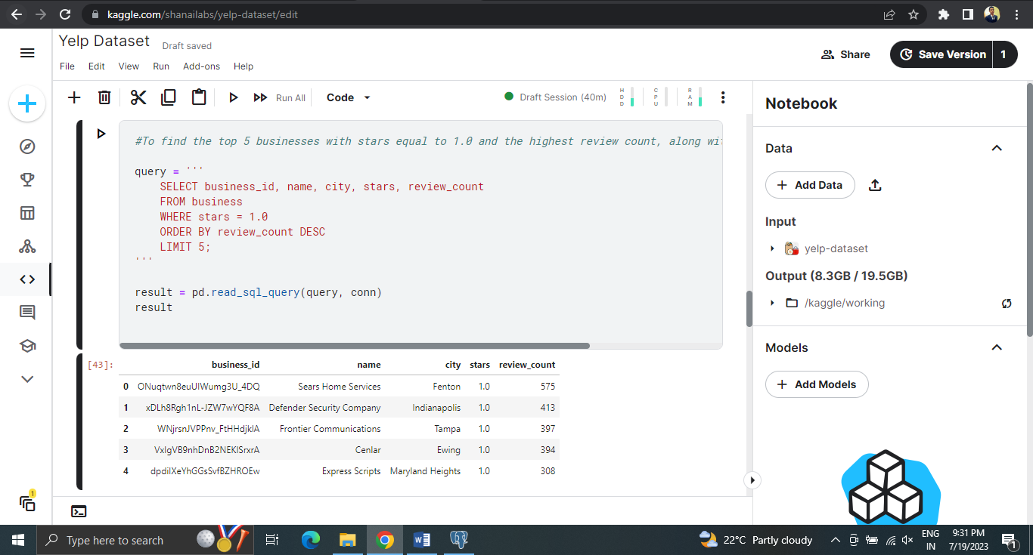

1. The below query is to find the top performing businesses with most 5 star ratings. This helps Yelp to identify the companies which have the most customer satisfaction, this can be used to give bonuses to the employees of the top business.

**SELECT business_id, name, city, stars, review_count**

**FROM business**

**WHERE stars = 5.0**

**ORDER BY review_count DESC**

**LIMIT 5;**

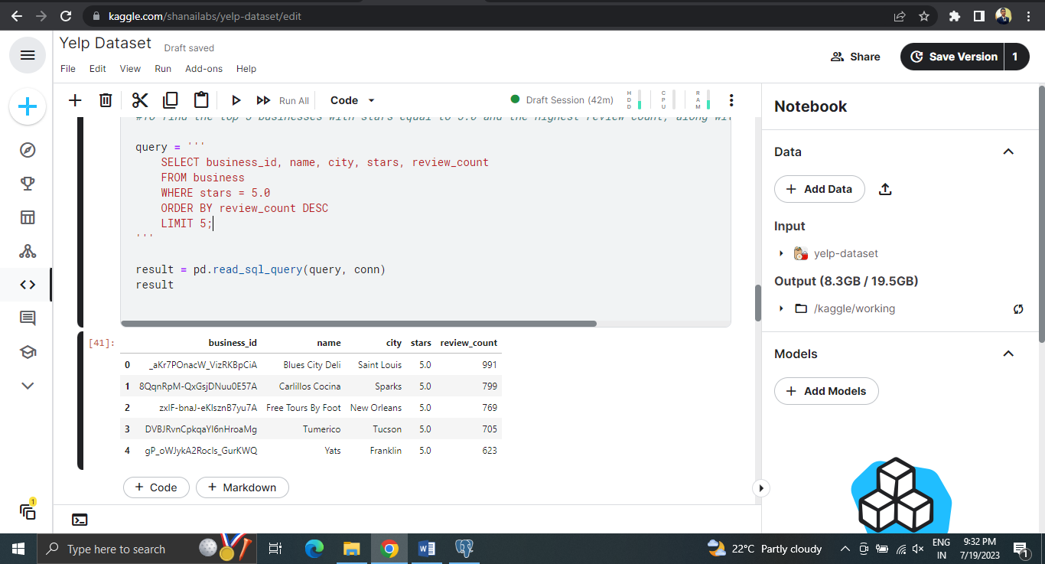

1. The below query is to find the most number of Business Categories.

**SELECT categories, COUNT(*) AS category_count**

**FROM business**

**GROUP BY categories**

**ORDER BY category_count DESC**

**LIMIT 10;**

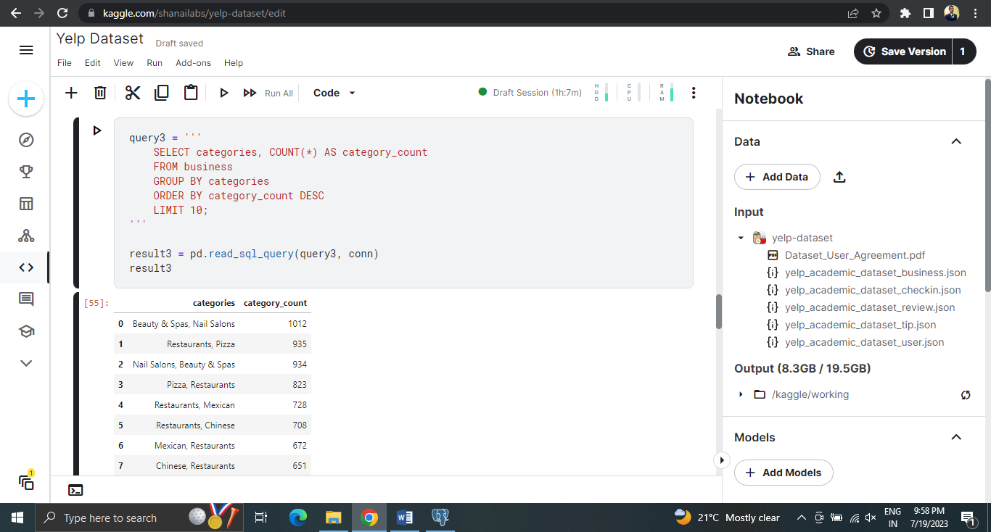

1. The below query finds the location wise businesses count and their average rating. By this Yelp can find which location is best to start any new business or improve the business in the location where the average rating is low.

**SELECT city, AVG(stars) AS avg_rating, COUNT(*) AS total_businesses**

**FROM business**

**GROUP BY city**

**ORDER BY avg_rating DESC, total_businesses DESC;**

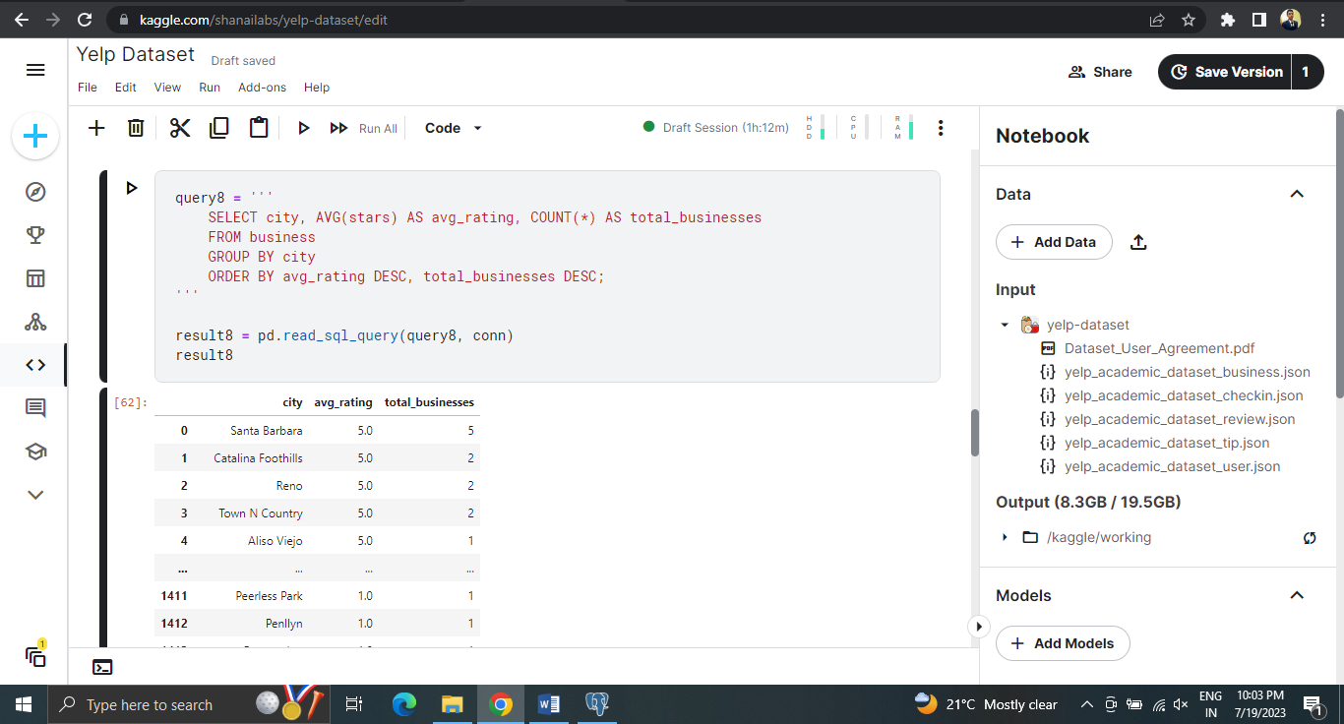

1. The below query is to find the active users by each month. By this Yelp can identify active user growth over the year and make sure the user base increases in the future.

**SELECT strftime('%Y-%m', yelping_since) AS registration_month, COUNT(*) AS    active_users**

**FROM "user"**

**WHERE yelping_since <= DATE('now')**

**GROUP BY registration_month;**

